**l**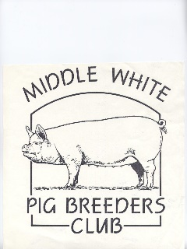

MIDDLE WHITE

PIG BREEDERS CLUB

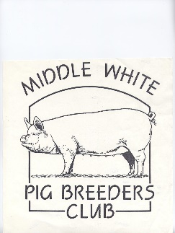

(PATRON: ANTONY WORRALL THOMPSON)

[](http://images.google.com/imgres?imgurl=www.mukwonago.k12.wi.us/mhs/sun.gif&imgrefurl=http://www.mukwonago.k12.wi.us/mhs/&h=272&w=296&sz=4&tbnid=V_PUveDTCVwJ:&tbnh=102&tbnw=111&start=4&prev=/images%3Fq%3Dsun%26hl%3Den%26lr%3D%26ie%3DUTF-8%26sa%3DG)

NEWSLETTER

SUMMER 2004

[](http://images.google.com/imgres?imgurl=www.mukwonago.k12.wi.us/mhs/sun.gif&imgrefurl=http://www.mukwonago.k12.wi.us/mhs/&h=272&w=296&sz=4&tbnid=V_PUveDTCVwJ:&tbnh=102&tbnw=111&start=4&prev=/images%3Fq%3Dsun%26hl%3Den%26lr%3D%26ie%3DUTF-8%26sa%3DG)

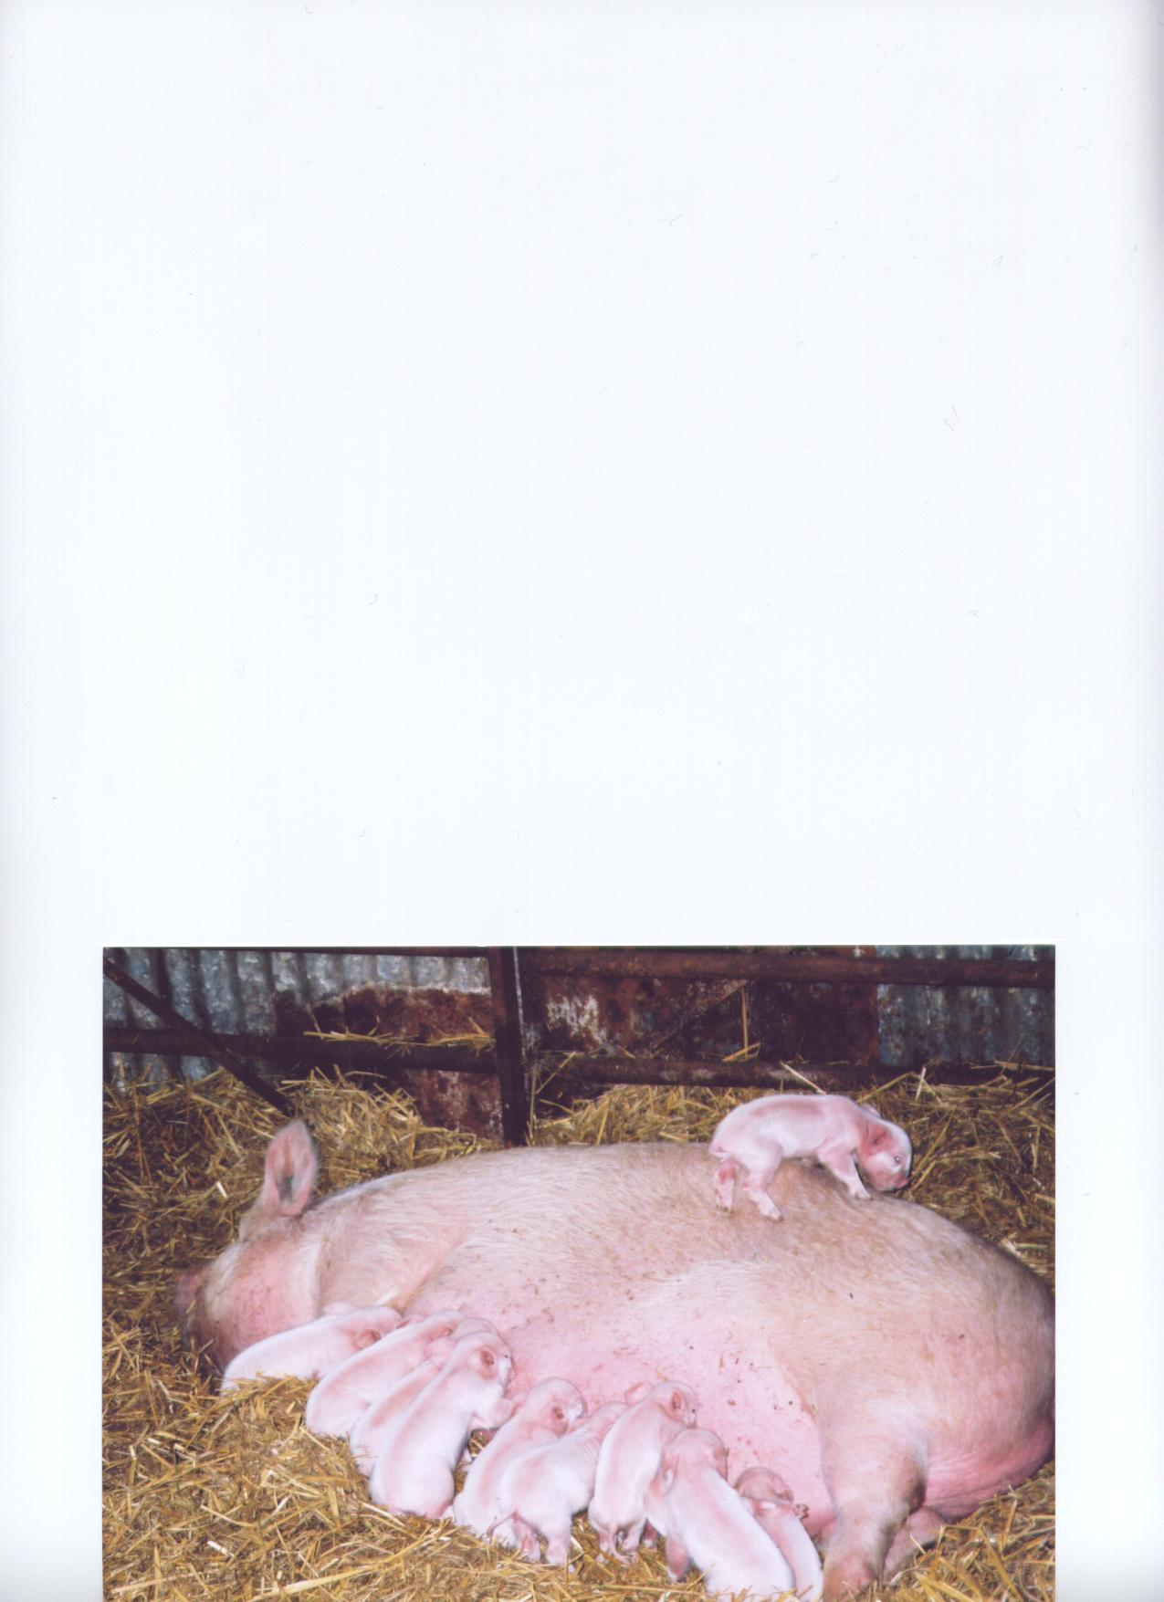

[](http://images.google.com/imgres?imgurl=www.dcresource.com/reviews/ricoh/ricoh-reviews/5000/flowers.jpg&imgrefurl=http://www.dcresource.com/reviews/ricoh/ricoh-reviews/rdc5000.html&h=1200&w=1565&sz=538&tbnid=hLpHoiIqCB8J:&tbnh=115&tbnw=149&start=4&prev=/images%3Fq%3Dflowers%26hl%3Den%26lr%3D%26ie%3DUTF-8%26sa%3DG) [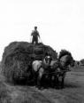](http://images.google.com/imgres?imgurl=www.pasty.com/crhm/pages/Kuurti/images/hay.JPG&imgrefurl=http://www.pasty.com/crhm/pages/Kuurti/kurtti_story.html&h=354&w=288&sz=14&tbnid=IEVipWXbpuMJ:&tbnh=116&tbnw=95&start=5&prev=/images%3Fq%3Dhay%2Bmaking%26hl%3Den%26lr%3D%26ie%3DUTF-8%26sa%3DN) [](http://images.google.com/imgres?imgurl=www.hoosiertimes.com/entertainment/games/cardshop/images/yellow-flowers.jpg&imgrefurl=http://www.heraldtimesonline.com/entertainment/games/cardshop/browse2-thinkingofyou.php3%3Fpapernumber%3D&h=367&w=475&sz=50&tbnid=HiXDIexX80AJ:&tbnh=97&tbnw=125&start=36&prev=/images%3Fq%3Dflowers%26start%3D20%26hl%3Den%26lr%3D%26ie%3DUTF-8%26sa%3DN)

OVER 150 YEARS OF THE MIDDLEWHITE

My name is Melissa Herbert, my grandpa is John Herbert and he has been breeding middle white pigs for 12 years, and for as long as I can remember I have been helping him show the pigs, clean them out and wash them.

I entered my first young handler competition when I was eight years old. Last year I spent three days at the Royal Show helping grandpa show the pigs and wash them. I was also helping other people prepare their pigs. I entered the young handler’s competition again and won a rosette.

I got my first pig for my 13th birthday last year in August, she is just over 12 months old and farrowed on the 12th May and had 11 piglets. She is called Dapple Heath Fair Lady 5th.

I like the pigs because I think that they are the most amazing creature on the earth and they are very intelligent.

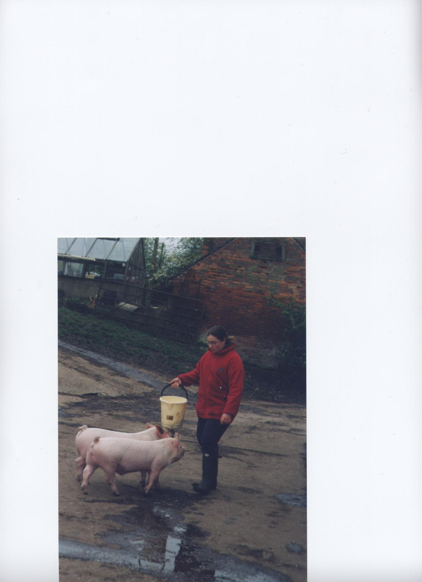*How lovely to see our younger enthusiasts writing a few words – last time Sophie and now Melissa, thank you. It puts the rest of us to shame! Miranda (editor).*

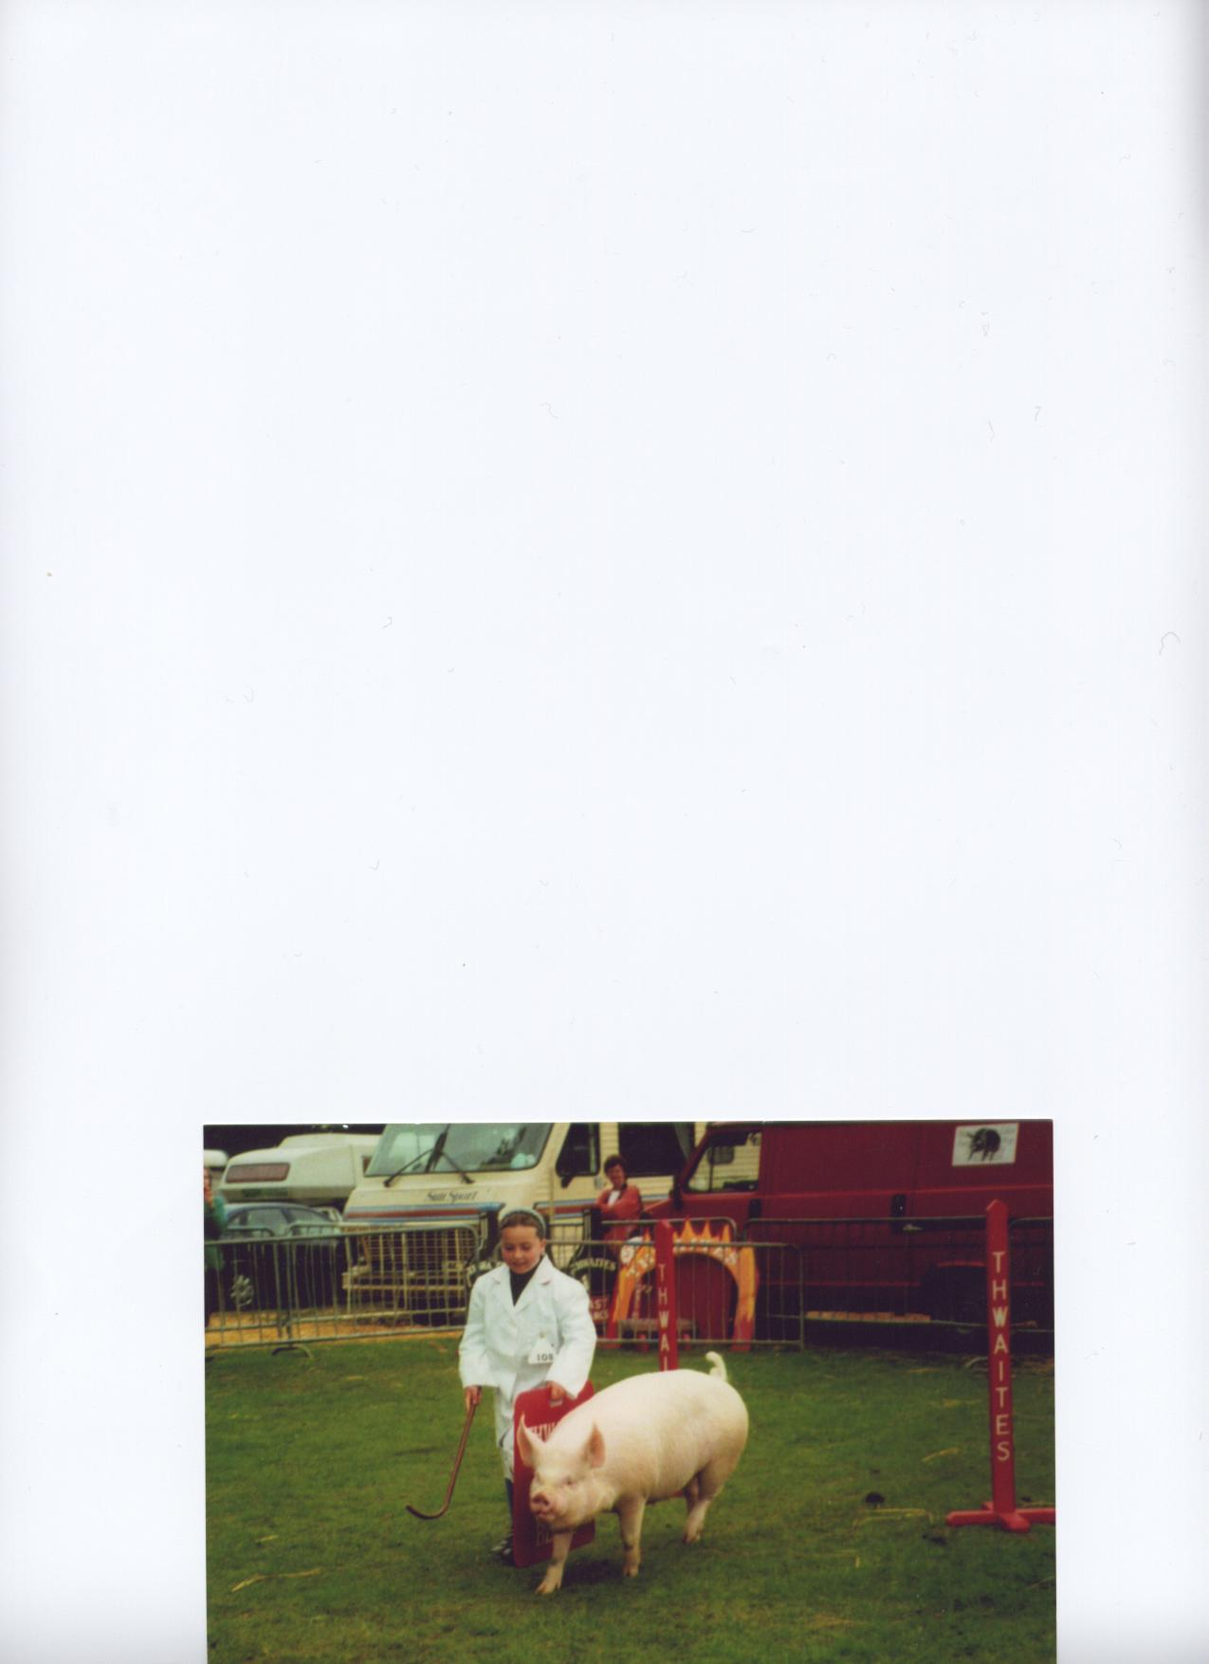

Melissa, aged 8, at the Royal Lancs Show

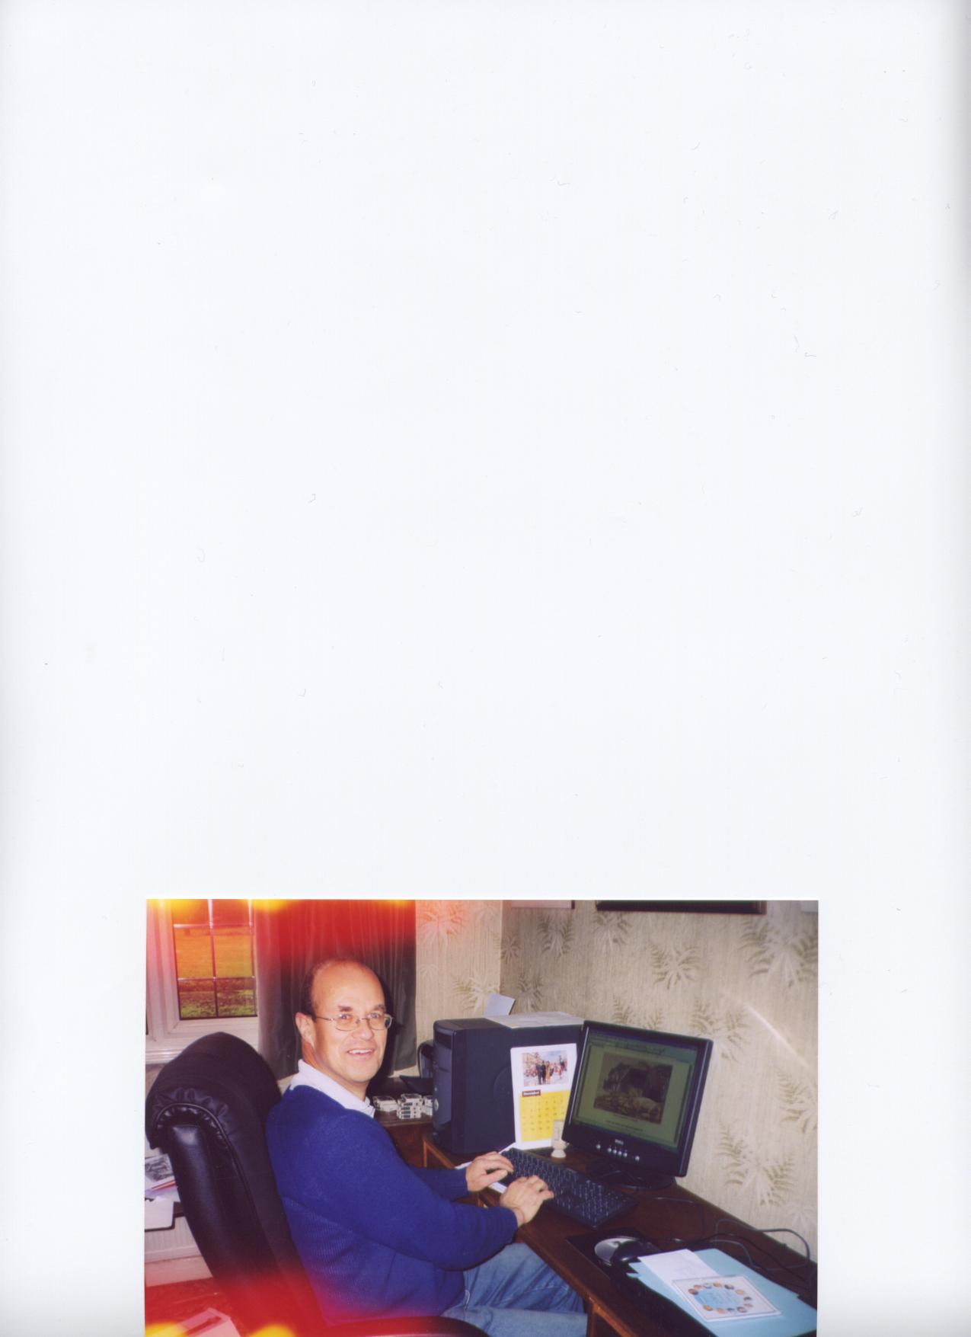

Your “trypist” hard at work on the Spring edition

Cover Picture

Charlmoor Silk 45th with her first litter (11-10), born January 22nd 2004. I adventurous body mountaineering! This was one of two Silk gilts purchased to ensure that we were able to keep

2

Melissa in April this year with granddad’s Januarys

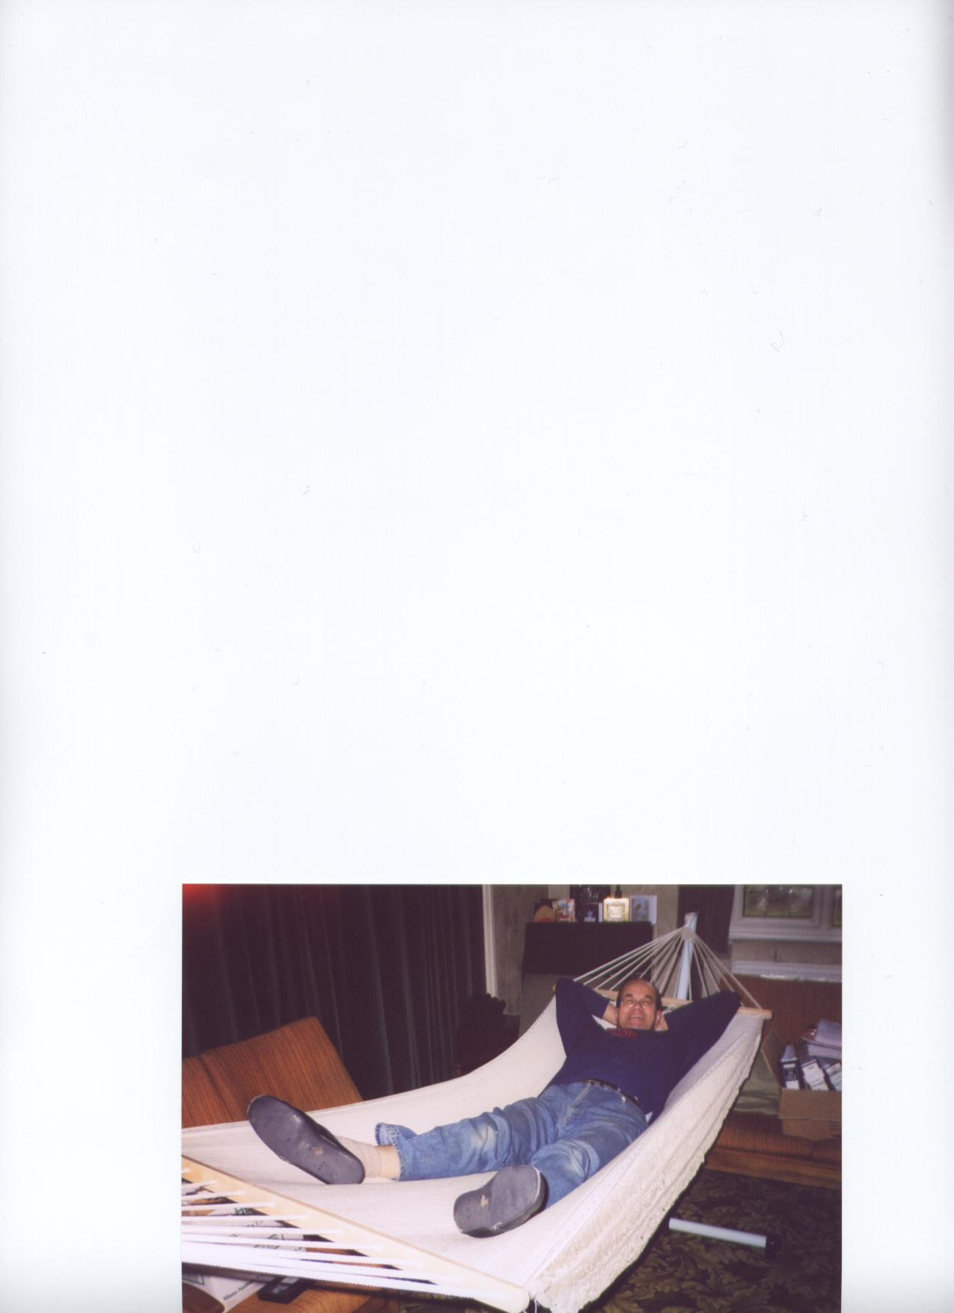

Phew! Finished at last

the line going. In December 2002 there were only 5 Silk sows recorded on the survey.

The four gilts from this litter have been kept and hopefully they will all go on to breed.

**CHAIRMAN’S LETTER**

Dear All, this will be fairly brief as I’m a little busy at the moment, with five Gilts due to farrow in the next week, plus one sow, who at least will know what she is doing ! I hope.

Some of you may have been wondering about my absence from shows this year despite having made entries, so I'd like to just reassure you that although all is not brilliant with the Middles health, or my own for that matter, it’s not that bad either.

I had my first case of Atrophic Rhinitis last September and despite an aggressive programme of treatment and vaccination the problem is still with me, though we have no idea as to where the infection came from. I advised all the "Cranborne Family" of Middle White Breeders whose pigs have been to visit my boars here at Boveridge to discontinue showing until we are certain we have got the problem under control. In fact many of the sows and gilts have come home again in order to assess them and treat them .I've therefore got an awful lot more Middles to care for than I should have, and haven't got time to go to shows .

I wouldn't like to spread any diseases to my fellow breeders or exhibitors so will not be showing at all this year but I hope to be back with a vengeance next year! I should add that the Tamworths and Large Blacks that Lord Salisbury, Bryan, Sarah and Billy are showing are kept on completely different sites and have had no contact with the Middles, and neither have the handlers.

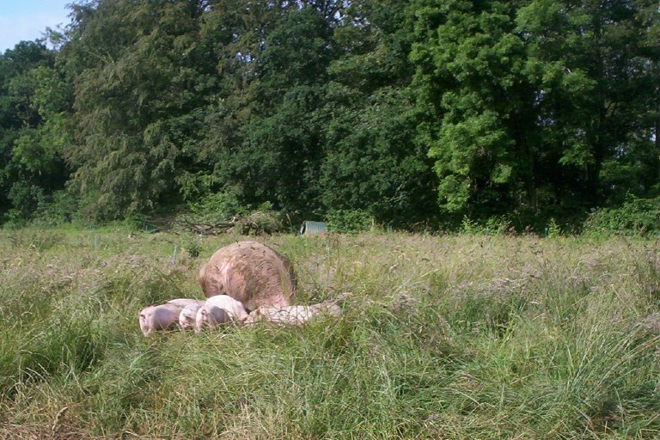

On a lighter note and with apologies to those of you who believe pigs should be rung in order to safeguard permanent pasture the photo to the left shows a paddock of about 50mtr square divided in two and occupied on a three monthly rotation!

Need I say more ..................

Best wishes to you all, Mary Card.

The ark is just visible under the trees. But how a piglet with eyes about 6 inches above ground level finds his way home goodness only knows!

**RAMBLINGS FROM THE SECRETARY**

Hello Folks and Friends,

Well, it seems that three months have gone since the last newsletter and it’s now time to put pen to paper again. The show season is well under way now, with the Royal the next major event in 10 days time (at the time of writing). I am sitting here with the rain lashing down and fifty mph winds howling round, and this is June!! When you think that a week or so ago we were so hot with the temperature up in the 80s – no centigrade here – and now a 30 degree drop, not good for the pigs but the ground certainly needed it. Making the grass and weeds grow! There have been reports of trees and electricity cables down, I do hope that not too many of you were affected. (I have since heard from Geoff Parker that some of the pigs were flooded out at Cheshire and had to be moved in the middle of the night.) Out come the thicker woolies again, still we should have known – it’s Wimbledon.

The early shows in the north have all had good entries of Middles, but the south haven’t been so lucky, with only the Bath and West and Cornwall having more than one exhibitor. I was very pleased to see a young lad winning 2nd and 4th in the January class at Cornwall, we certainly need a few more youngsters coming into the breed, Well Done!

3

Days later – After another wet Sat and Sun afternoons the weather has improved at last, let’s hope it stays dry now for the Royal, showing is so much more fun in the dry.

Just a few words regarding Mary’s letter. She agonized over what to write for a long while but I feel that she has done the best thing, to silence the speculation over her absence from the show ring. I’m sure that you will all join me in wishing her a speedy resolution to the problems, and that she will be exhibiting next year.

Regards, Miranda Squire.

-oooOOOooo-

Below are some photos to accompany Jack Howlett’s article.

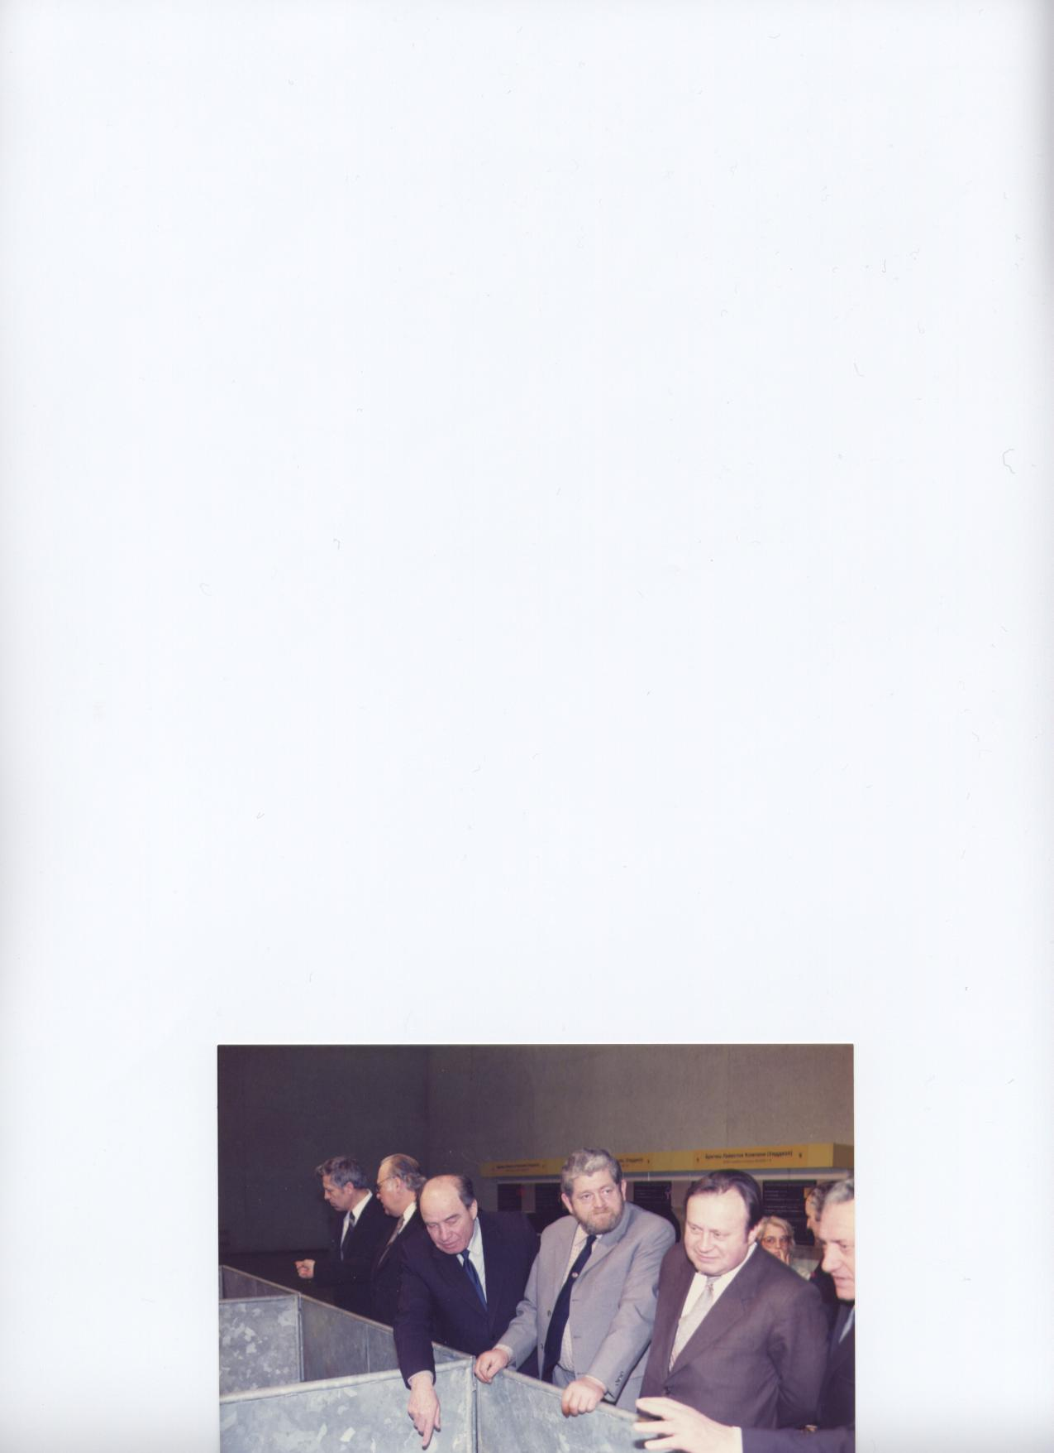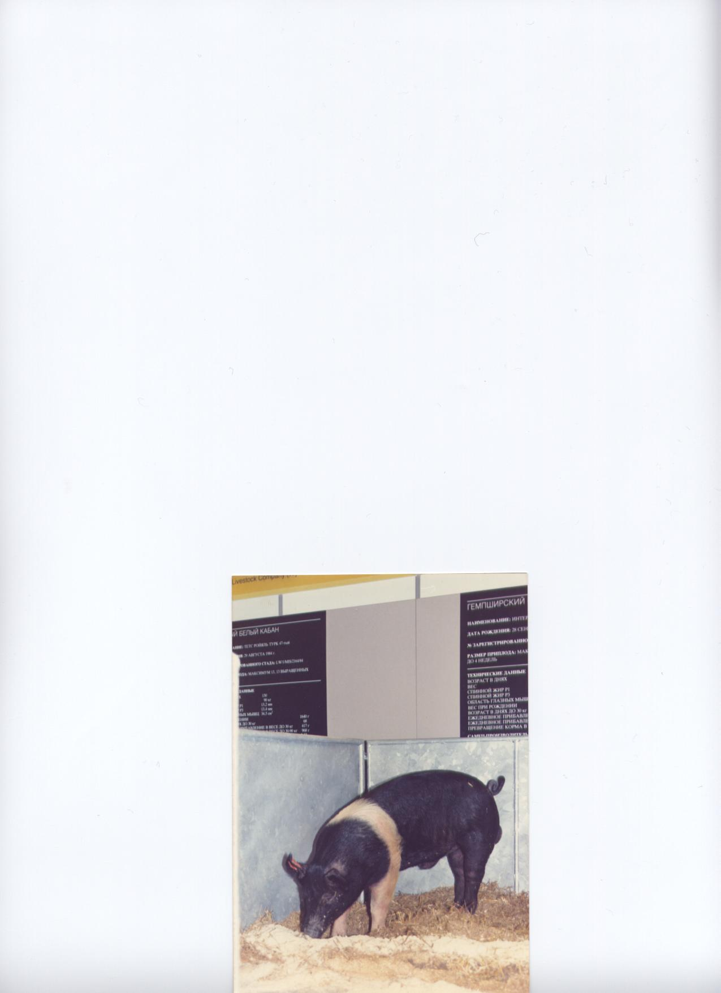

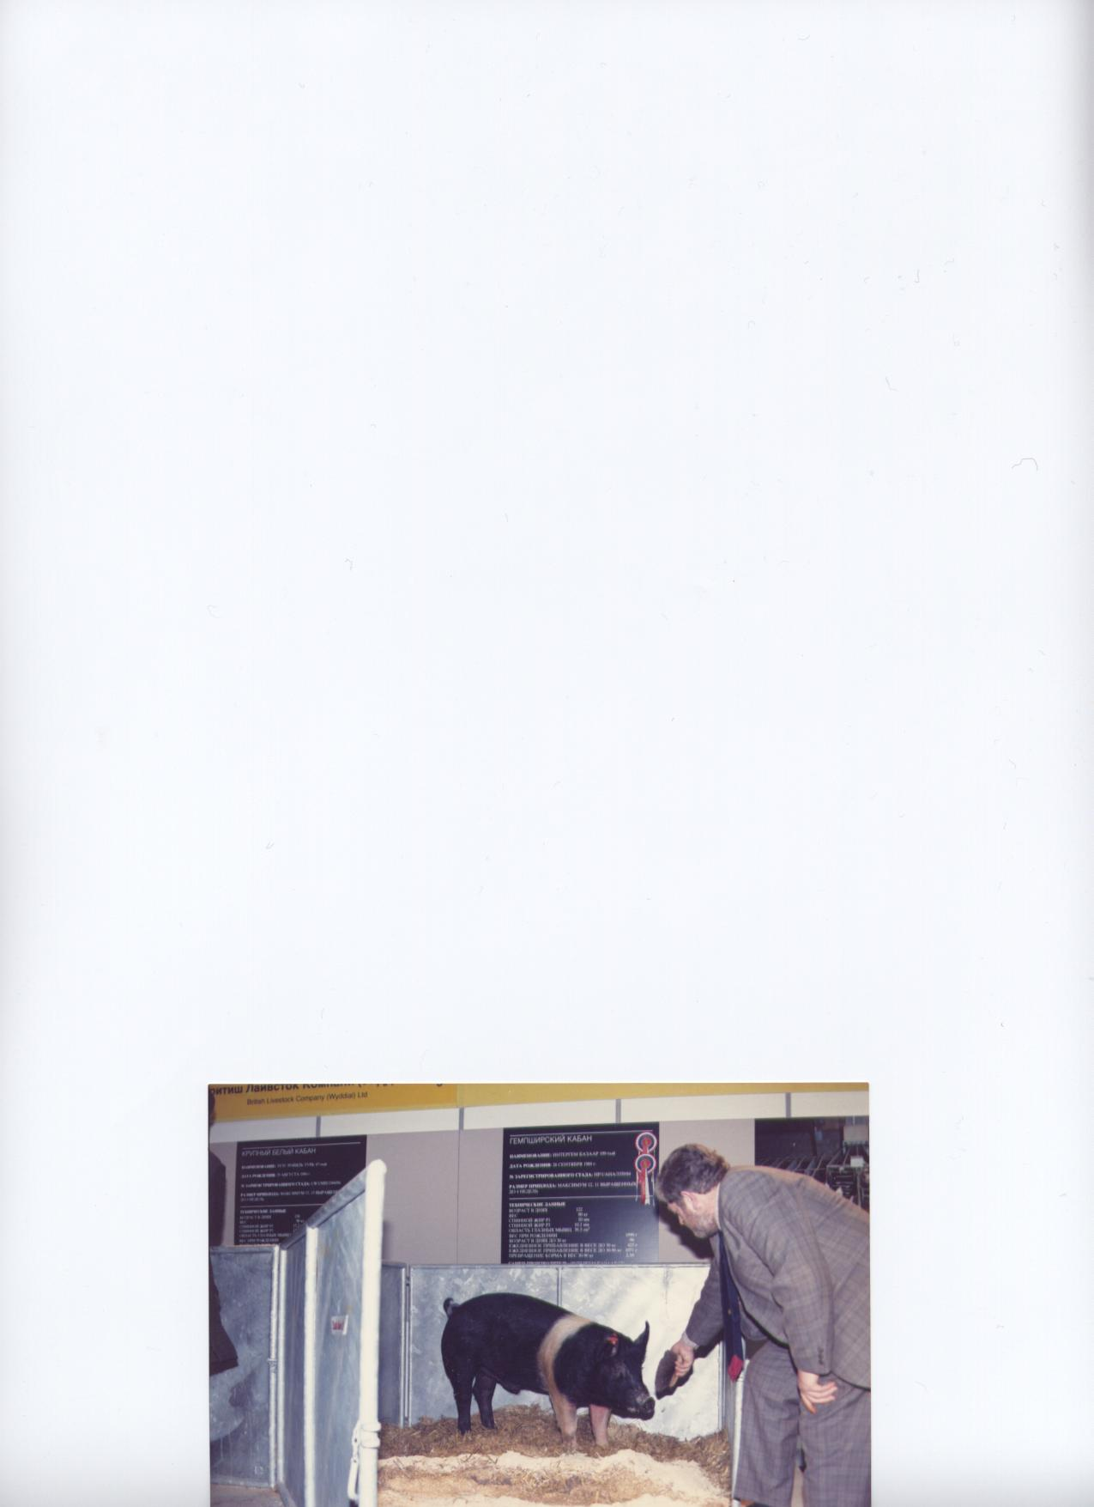

Above left - A smart “Bazaar” Hampshire

Boar, Britagroprom, Moscow.

Above right - JH with the Russian Minister

of Agriculture (right), Britagroprom

Moscow .

Left - JH with one of the Hampshire Boars

exhibited at “Britagroprom” in Moscow

4

**EXPORTING TO THE FORMER SOVIET UNION**

To succeed in this world of ours, it is not always what you know, but who you know. This was the case with our introduction to the Russian market. A colleague of mine, Gilbert Barling, who had exported livestock before the Second World War, was the son of a former Newmarket race horse trainer, who had won a Derby in the 1920’s. Gilbert had many friends in the racing world and when an inquiry for farm livestock went to the British Bloodstock Agency it was passed to us.

The original inquiry was for cattle, sheep and pigs, and Gilbert and I were asked to attend a meeting at the office of the Russian Trade Delegation, based on Highgate Hill in North London. The entrance to the heavily guarded complex was protected by a 10 foot high iron barred gate, after about a half minute the gate slowly slid right to left, time enough to drive through and then the gate closed behind us.

The Russian Trade Delegation was an impressive building, with a very smart reception area. We were shown to one of many interview rooms and offered good coffee with biscuits that were past their best. The Russian negotiating team consisted of 4 men, including the head of the delegation and one secretary. They confirmed their interest in cattle, sheep and pigs.

Having seen the health protocol for all 3 species in advance, we knew that this would be our biggest problem. The Russians insisted that it would be difficult to change, despite the fact that many of the diseases mentioned in the protocol did not exist in the UK, or better still, never had existed in the UK.

The chief negotiator told us that Galloway cattle were required for one region of the Soviet Union, Friesian dairy cattle for another region. Also they were interested in several breeds of pig, including Large Black for the Baltic States and sheep of various breeds to suit regions with contrasting climate conditions. It therefore looked like a contract that was worth fighting for!

The first meeting ended in deadlock, however, we were encouraged by the fact that another meeting was arranged for the following week. The second meeting was very similar to the first with very little progress made. The third meeting was very tense, but I did manage to break the deadlock regarding the health certificates. I suggested that one of our vets attend the next meeting and the Russians agreed. Our vet was Alex Morton and I told him to study the Russian health certificates in order that changes could be negotiated, to make it possible for us to comply.

The meeting took place on a Thursday and eventually the Russians said “Dr Morton, if you rewrite the certificates by 9am on Monday morning we will consider them favourably”.

Alex did a great job and at 9am on the Monday morning revised health certificates were presented for Russian approval, and with very little argument they were agreed.

We were then in a position to offer quotations for what turned out to be a boatload of stock. The British M.A.F.F. was also informed that a new set of protocols had been agreed, with a covering letter from the Russian Trade Delegation confirming the fact.

I knew that M.A.F.F. would be unhappy that we had negotiated the new protocol; we also knew that had it been left to them it would have taken at least 6 months, possibly more and this would have meant losing the business.

Sure enough a few days later a letter was received from M.A.F.F. demanding a meeting. We arranged for a meeting to take place at our office, there is a big advantage having “Home Territory”

for a meeting of this kind!

5

The “Two Men from the Ministry” arrived in smart suits and winkle-picker shoes. They were not vets but administrators. This was typical of M.A.F.F. at that time, with administrators making the decisions over the heads of the vets. This is why it took so long to get agreement about health certificates, or for that matter, anything else.

The meeting opened by MAFF scolding Alex Morton and myself for having the audacity to negotiate a health protocol with an important country like Russia. I said that if anyone was at fault it was me, as I had asked Alex Morton to put forward recommendations. MAFF insisted that it was their job and we said that we would have no objection to MAFF negotiating health certificates, but they always took so long that it often cost the UK valuable livestock export contracts, in this case time was the key factor.

We took “The Men from the Ministry” for lunch and they promised that in future they would get agreement on health certificates as quickly as possible. After that things did improve slowly. New vets took over in the top jobs and gradually they were able to take control, with the administrators only consulted regarding the wording of the protocols.

We haggled over the prices with the Russians for a while, but soon all was agreed and ready for contracts to be signed. There then followed what was to become a regular ritual. A bottle of vodka was produced, still wrapped in tissue paper and following the contract signing, the bottle was opened, the top thrown into the waste paper basket and the contents consumed until the bottle was empty. The quality of the vodka was far superior to anything one could buy in the UK and we suggested that if this quality vodka was marketed in this country it would be very popular!

For the first contract Russian specialists in cattle, sheep and pigs visited the UK to select. We were lucky enough to have an interpreter, born in England, with both parents born in Russia. Her Russian was so perfect that our visitors could not believe that she was born in England. Nina had acted as an interpreter at a British Livestock exhibition in Moscow in the mid 1960’s, so was very familiar with livestock terminology etc.

I do not remember the exact number of animals shipped, but I know there were 100+ Galloway and 120+ Friesian cattle, 80 pigs and several hundred sheep. The pigs included about 25 Large Blacks, which were for the Baltic States. In Eastern Europe the Large Black breed is called the “Cornwall”.

All the animals were shipped in one load from Lowestoft on the east coast, through the Kiel Canal, into the Baltic Sea and then on to Riga in Latvia, then still part of the Soviet Union.

The stock arrived in good condition; however our attendant was very upset when all the boars were put together in one railway truck. It was disappointing as every effort had been made to keep all the boars in separate pens both during road transport and on board ship. Running boars together appears to have been fashionable in Russia at that time and I saw several examples of it in later trips to the Soviet Union. About 3 months after the first shipment we had a claim for one Large Black boar that had died in transit. The accompanying vet certificate stated that the boar had died due to “travelling sickness”.

Further contracts were signed and a senior Russian Ministry Livestock official was in the UK selecting a second load of Friesian cattle. We showed him the claim and explained the circumstances and he guaranteed that in future all imported stock would be handled properly.

Several more mixed loads were successfully shipped in the same way.

In the early 1980’s the Board of Trade, together with the British Agriculture Export Council (BAEC)

6

proposed an agricultural exhibition in Moscow, it was to be called “Britagroprom” and it had the full

support of the British Government. The first show was arranged for February 1982 and I was part of an advance party, made up of representatives of companies that had agreed to take trade stands.

The group consisted of 8 persons, led by John Thornelow, the chief executive of BAEC.

We were met at Moscow International Airport by diplomats from the British Embassy and taken to the National Hotel on the corner of Red Square and Gorky Street. The first day in Moscow was taken up by a “brainwashing” session, when a series of speakers told us what a wonderful and productive country the Soviet Union was. Some of the statistics quoted gave the impression that the Soviet Union was producing enough food to feed the entire world. Wheat and barley at least 10 tons to the hectare and cows that were giving 14,000 litres **o**f milk in a lactation, were dramatic figures I remember being quoted.

That night we were taken to the “Hall of the People” that was part of the Kremlin to see a programme of ballet. The following day we toured various Ministries, St. Basil’s Cathedral and the Kremlin, followed by a night at the Bolshoi Ballet.

On the third day following further meetings in Moscow we were booked to travel on the overnight train to Minske, in White Russia, now a separate country named Belarus. When we left the hotel to catch the train, it was about 10 o’clock at night and Red Square was full of tanks and with each tank there were fully equipped soldiers standing to attention. We were assured that it was just a training routine, however one of our group was very upset.

On arrival at the station we were shown to our sleeping compartments and then to a lounge area where we had drinks served. Our official interpreter and minder was a very well dressed young man named “Sacha”, his real name was Alexander, it appears that all Alexanders are called “Sacha”. We were all having a good time telling stories over a drink. There was a pause in conversation and Sacha said “what shall we talk about next? I suggest that we talk about the Supreme Soviet”. This suggestion was met with a very emphatic “NO”.

I often wonder what happened to “Sacha”, he obviously had a great future in the Supreme Soviet and was fully brainwashed, the only problem was that there was no future for the Supreme Soviet!!

On arrival in Minske we were taken to a Garden of Remembrance in honour of 50,000 women and children of White Russia, supposedly murdered by the Germans during the second World War. Our guide was very convincing and tears ran down her face as she described the many villages completely wiped out by Hitler. A muffled bell tolled every 30 seconds day and night, which made for a very sombre atmosphere. Two years later we learned that it was Stalin who was responsible for all the murders in the region, not the Germans.

On the second day in Minske we were taken to a turkey farm. I must admit that I have never been particularly interested in turkey production, or for that matter eating turkey.

We arrived at the farm at 10am and we were greeted by the manageress, she was a very large lady with big bosoms, she kissed and hugged us all. The company was appropriately named Titsiprom. We were shown turkey house after turkey house, they all looked the same to me, but we continued. At 1pm we were still looking at turkey sheds and when the clock reached 2pm we were almost resigned to the fact that we would not get any lunch that day, and so it went on until 3.30pm when we were shown into a hall, where a banquet was awaiting us, a turkey for every two people and bottles of vodka, at least one per person.

7

All through the meal there were toasts and speeches and as more vodka was consumed the speeches became sillier and sillier. Our leader, John Thornelow, went as far as to say that the Soviet Union was similar to the United Kingdom, both were made up of several republics. John then listed The Republic of Northern Ireland, The Republic of Wales, the Republic of Scotland and the Republic of England, everyone clapped and shouted, again another toast. To end the banquet “Miss Titsiprom” kissed and hugged us all again and we returned to our hotel, just a little worse for wear at 6.30pm, to be told to be ready in half an hour for another bash. Half of the group went to bed, the rest of us were taken to a restaurant for what was, luckily, a quiet dinner.

In the restaurant were about 6 tables, each with about twelve ladies enjoying a meal. We were told that these “Ladies nights out” were given to factory workers, in place of a bonus for good productivity.

The mission had created a lot of interest in “Britagroprom” that was to take place 3 months later. Everything for the exhibition was prepared and built in England and transported by road to Moscow. The stalls for our cattle and pens for our pigs were built to our specifications. A British catering company was employed and all the food and drink for British stallholders and invited Russian guests was sent out from the UK.

After consultations with the Russian Government, we exhibited 10 top quality Friesian bulls, 2 Large White and 2 Hampshire boars. We were unable to find an airline prepared to take a small consignment and so our exhibits went by road. Not ideal in winter, however the bulls and boars travelled well, the journey took a week and the biggest problem was getting supplies of water and keeping it from freezing solid.

I flew out on the Sunday before the show opened and had problems getting through passport control. My passport photograph was taken with me clean shaven, but when I arrived in Moscow I had a beard. I was taken to an interview room for interrogation and it took about an hour to convince the officials that the photo was of me!

“Britagroprom” was a great success and the catering arrangements were ideal. We had a lady interpreter named Ena, she was the wife of a Russian diplomat and had lived in Washington for several years. Having got to know Ena quite well, she told us that the next president would be Mr Gorbachev and that things were about to change.

The president of the British Friesian Cattle Society was due to arrive in Moscow on the second day of the show and I was to meet him at the airport. I had great difficulty in getting a taxi, there were plenty available but none would take money, so one had to barter with them, all they wanted was vodka or cigarettes, commodities that Russians had difficulties in buying.

On another occasion I was invited to have lunch at the private residence of the first secretary commercial, British Embassy, on this occasion I could not get a taxi at all and had to phone and regrettably cancel.

The Russians certainly supported the show and all their top officials attended at least once, and some of them on several occasions. The top Minister of Agriculture spent over an hour at our stand and most of the time was spent telling him how lean and fast growing British pigs were.

We told him that British pigs could improve the quality of pork in Russia. The minister then said that in the Soviet Union everyone over 50 years of age preferred fat to lean – it was difficult to answer that, but we did tell him that young people throughout the world now wanted to reduce their fat consumption for health reasons, he had to agree the same did apply in Russia.

8

One evening during the show we were invited out for a meal and cabaret at a restaurant in the suburbs of Moscow. The food was not up to much and the show was a kind of static historic tableau type of production, and with the words all spoken in Russia, not very interesting. One of my colleagues, a vet who was to speak at a seminar the following day on embryo transplant, suggested we leave the party and try to find a meal in town. With a bit of luck we found a small cellar bar with a sign outside saying “food for dollars available”. There were two tables occupied by young men drinking vodka, not an unfamiliar sight in Moscow, and one table for two which we occupied and had steak and chips. Up to this point it was the best Russian cooked food that we had tasted. The vodka drinkers were by now getting very merry as they called for another bottle. One spoke a little English and they insisted that I was Peter Ustinov, the actor, as I mentioned earlier, I had a beard at the time. They were so persistent that my colleague suggested that we play along with them. Next thing they wanted autographs. This was a problem as neither of us was sure how to spell Ustinov. My new found “Fans” were by then, too drunk to notice!!

Next day at the show my colleague had told others and my leg was pulled for the rest of the day.

The same colleague reserved seats at the Moscow State Circus, he also booked a taxi to take us there. It was fantastic show. It was very warm in the arena, but when we came out we realised that no taxi had been booked to take us back to the hotel. I did not take an overcoat as I thought transport both ways had been arranged. The temperature that night was -25degrees C, and I have never been so cold in my life. Fortunately a taxi was soon found and in next to no time we were back in our hotel.

The dining room was still open and we were able to get some hot soup to warm us up. On the stage in the dining room was a ladies balalaika band playing Russian folk music. There were nine players and despite the happy music, not one of them smiled once. It may not sound all that funny second hand, but I can assure readers that at the time it was hilarious.

At the show on the last day, I was asked to do an interview with a Russian journalist. Moments later one of the British Embassy staff caught my eye and beckoned for me to speak to him. He said be very careful what you say to him, he is the Robin Day/Jeremy Paxman of Moscow television and will twist everything you say to the Supreme Soviet advantage. I am glad that I was warned as this man did ask some very leading questions!

Looking back, all of us who attended “Britagroprom 1982” can remember a most enjoyable and worthwhile week. As a result of the show more cattle were exported, to the Ukraine in particular. Also an order for 40 Large Black boars was received and I had great difficulty in finding enough boars to fill the order. Fortunately the contract allowed for pigs 3-8 months of age and one breeder had a litter including 6 boars, all of which were good enough, and the full order was completed.

My last visit to Russia was at the time that the Supreme Soviet was disintegrating. We had a delegation from the Samara region visit us. They were a high powered group that were looking for a good time. We noticed that whenever we went to a restaurant they always ordered the most expensive dishes on the menu, as it was at our expense.

Letters of intent were signed and countersigned indicating their interest in large quantities of breeding pigs to improve their existing stock. It was agreed that I should visit Samara with a nutritionist for further negotiations.

The nutritionist was from Tucks of Burston and we arrived in Moscow to find out that my colleague’s luggage had been lost. This meant that we missed our flight to Samara and had to spend the night in a hostel. There was no food available and we had to walk for miles to find something to eat.

9

Next day, still no luggage, so we set off to the domestic airport, some 20 miles the other side of Moscow. How we ever found the correct plane I do not know, it was complete and utter chaos. We arrived in Samara to be met by our interpreter, who had been waiting for almost 24 hours.

The following day we met the “top brass” that had visited the UK the previous month. It appeared that all they did was drink vodka or brandy and talk about more letters of intent.

We visited several very big pig farms and found out just how bad Russian agriculture was, there was no protein available for pig feed. We were shown row after row of sow and litter pens. The sows were thin and undernourished and the litter size was between 2 and 5. The young pigs were weak and very thin. On the farms we saw several tubs of skimmed milk and when we asked how it was used we were told that it was fed to the stud boars to keep up their fertility.

The boars were in yards of 20 or more, all old boars with uncut tusks. They were all very, very fat, in fact the fattest I had ever seen. We then visited the artificial insemination centre and were introduced to three elderly ladies, all said to be professors of animal reproduction! They admitted that the results of AI were not as good as they would wish and asked if we could help. My first comment was to the effect that if AI was not producing good results then the first thing to do was to revert to natural service, they replied “but that is old fashioned”, to which I replied “there is nothing more old fashioned than not getting your sows pregnant”.

Despite all the gloom on the pig farms we continued to be looked after very well. We were taken to a school, in order that the pupils could see what a foreigner looked like. Samara had been out of bounds to all foreigners for more than 40 years as it was a region where rockets and secret weapons were made and tested. That night we were entertained by the second layer of bureaucrats and their wives. Despite the general shortage of food in the country the tables were laden with food, including golden caviar and many other local delicacies, and of course, the usual vodka and brandy.

On another day, after visiting more pig farms, all with the same problems, in the late afternoon there was a very pleasant treat for us. We were shown to a clearing in the woods and there we met a genuine entrepreneur. This man was of Polish origin and had a mobile apiary, 16 beehives mounted on a lorry. He lived in a caravan and this was his winter residence. There were fairy lights hanging from the trees and a log fire. In the summer months he hooks his caravan to the lorry and drives south in order that his bees can find different types of pollen to make their honey. He also sells his produce in various resorts in Southern Russia.

The man cut large slices of freshly made bread, which we ate with large quantities of superb honeycomb, straight from one of his hives. As we enjoyed this interlude in the cool of the evening I could not help remembering a poem by Rupert Brooke that ended “And is there honey still for tea?”.

This, we thought, was to be our evening meal, we were wrong and we were taken to a farm workers house, where a traditional evening meal was being prepared. All the men sat in a circle on the floor. The food which consisted of chunks of mutton and pork, with many vegetables and spices was served in a receptacle that looked rather like an upside down dustbin lid. It was tasty, but the honey had taken the edge off my appetite. I did ask why there were no ladies present, to be told that a women’s place was in the kitchen. I never did find out if, in fact, it was an obscure religious belief, or just bloody-minded sexism!

On the last full day of our visit we were taken to two very large grain storage plants and shown how much corn they could store. Both plants were absolutely empty and we were told they were waiting

10

for refurbishment! For these visits we had “top brass” bureaucrats to accompany us.

Finally our mini bus drove into a very muddy farm yard, where we expected to be shown empty corn bins. The mini bus backed up to a door in a shed and we were led into a luxury lounge. We were offered more drinks and then asked if we would like a sauna. This was followed by a cooling off dip in a small pool, there was even a servant to whip you with birch twigs, in order to get the maximum benefit from the sauna!

I had never experienced a sauna before and I have to admit that it was very exhilarating, and all that vodka consumed during the past few days was sweated out and I felt like a new man. We then were entertained to a slap up dinner, including real black caviar, the kind that sells in Selfridges food hall at £500 for a 200 gram tin. As we sat round the tables in the dressing gowns provided, it certainly opened my eyes regarding the sheer hypocrisy of communism, or was it that the “top brass” were having a last fling before the inevitable changes were put in place!

We had to be at the airport at 6am the next day, we boarded the plane at 8am and then sat for a further 5 hours before the plane took off. We were told that the airline had insufficient funds to pay for the fuel. The chaos at Moscow domestic airport was even worse than that experienced on the outward journey. We managed to get seats on a mini bus that took us to the international airport via the city centre. We were told that the only food in the city was a Kentucky Fried Chicken and a McDonalds, outside each of their restaurants there were queues 400 to 500 yards long!

This was not quite the end of our adventure, we boarded the Aeroflot flight to London, it was very full and the stewards kept counting the passengers, eventually it was announced that the plane had one passenger too many, so all the boarding cards had to be checked.

The man sitting next to me did not have a boarding card or a ticket or a passport. After further discussion he was allowed to travel! How he got on at passport control at Heathrow, we did not wait to see – he could have been an illegal immigrant!!!

Next time, if you are still interested, my experiences in China. Jack Howlett

A few words from Tracey Bretherton who was voted onto the Committee at the A.G.M. to replace Mervyn Forster, who felt that he had too many other commitments to be able to do the Club justice.

When I worked on a smallholding and cattery, they used to keep a couple of weaners to run on for pork and from then on I always wanted to have pigs of my own. When we went to the agricultural shows the pig pens would be the first place of call.

So when we bought a smallholding of our own we kept a few for pork then foot and mouth hit so we didn’t have any, until we went to The Royal Show in 2002.

Ian had promised to buy me a pig as a wedding present but that got put on hold with foot and mouth. So when we went with a couple of friends to The Royal Show in 2002 the lads headed of to machinery and the girls to the animals. We had agreed to meet up for lunch but as soon as we hit the pig pens and found Peggy (Cestrian Woodlands Lady 4) the mobile was out. Geoff had said she was for sale and was in pig, the beginning of a dream. We arranged to pick her up on august the 10th so that she had been scanned and was definitely in pig.

Unfortunately she didn't eat for a week and seemed to miss the other pigs, and the vet

11

seemed to think she had absorbed the piglets. So as you can imagine I was never of the phone to Geoff, he must have been really sick of me. Anyway we arranged to take her back to be served. As Geoff had nothing to go with her we decided to buy some weaners. So Alice (Cestrian Yootha 24), Amy her sister (Cestrian Yootha 25) who was supposed to be for pork and Archie (Cestrian Revival 6) who was also supposed to be for pork. The idea was that Peggy would have company with Alice when she was a little older. When we went to collect them Geoff said he had herd booked them all and if we wanted to keep Archie he wasn't related to any of the girls. So next time we could use him instead of traveling. So my dad missed out on his pork dinner and we kept them all.

Peggy had 7 in her first litter and it all went well.

Amy's litter was 11 and she hated them but thanks to Brian, Geoff and Miranda and all their advice we got her settled. It’s so good when you know help is only a phone call away, and when you’re very new to all this, advice is always welcome. Alice's litter was great she had 10 all by herself despite Ian staying up till 3am with her then deciding she had settled he went to bed. When I checked on her at 4:30am 10 little heads were suckling away.

Ian has got right into the pigs now and is nearly as bad as me. Although he would never admit it.

This year you should see us showing a couple we have bred for the first time, so let’s hope for a little success. We have both enjoyed showing. Last year we did really well and the saying is definitely true, :- There is no one friendlier than the piggy people!!!.

Tracey Bretherton

**FOR SALE**

Middle White Boars.

Smallicombe Revival - Reserve Champion Middle White at Royal Cornwall Show.

Phone Ian and Maggie Todd 01404 831310

---------------------------------------------

Waltham Mischief, Sire = Shoff Mischief, Dam = Colony Frieston Fair Lady 510

D.o.B. 20th October 2003

Phone Mrs Hutson 01472 824183

---------------------------------------------

Lowerdale Sovereign WRL/323, Sire = Dappleheath Sovereign 3, HJH/564, Dam = Cestrian Woodlands Lady 12, PGK/321

D.o.B. 14 February 2004-06-23

£100.00

Phone Angela Roberts 01768 773452 (Nr Keswick, Cumbria)

12

**SHOW RESULTS**

The Show Season started on 2nd May at Lambourn. After days of rain and cold winds the Sunday started with cloud but turned into a glorious day. (The following day was back to rain).

Sadly with only 13 pigs forward there were only two Middle Whites, both from Mary Card, her Sow Westham Fair Lady 285 and Gilt Gillhouse Fair Lady.

The Champion went to Lord Salisbury’s Tamworth Sow with reserve to Bryan Card’s Large Black.

**NEWARK AND NOTTS 8-9th May Judge - John Mason**.

Group of Three 6 entries

1. Saddleback
2. Gloucester Old Spot
3. Middle Whites – Geoff Parker

Boar Born 1st July to 31st December 2003 10 entries

2) Cestrian Mischief 16th – Geoff Parker

Female Born Before Dec 2002 12 entries

1) Lop

3) Cestrian Yootha 24th Tracey & Ian Bretherton

4) Cestrian Yootha 25th Tracey & Ian Bretherton

Female Born in 2003 – 1st January to 30th June 7 entries

3) Cestrian Woodlands Lady13th Geoff Parker

4) Cestrian Woodlands Lady11th Geoff Parker

6) Colony Frieston Fair Lady12th North Sea Camp

Female Born in 2003 1st July to 31st August 9 entries

1. Gloucester Old Spot
2. Cestrian Woodlands Lady 18th Geoff Parker
3. Cestrian Woodlands Lady 18th Geoff Parker

5) Cestrian Almarose 5th Geoff Parker

Female Born 2003 1st September to 31st December 15 entries

3) Gracebank Yootha 2nd Tracey & Ian Bretherton

4) Eves Almarose 3rd Mike Paddock

**Best Middle White Boar**

Cestrian Mischief 16th Geoff Parker

Reserve

Eves Captain 54th Mike Paddock

**Best Middle White Sow**

Cestrian Yootha 24th Tracey & Ian Bretherton

Reserve

Gracebank Yootha 2nd Tracey & Ian Bretherton

**Champion Middle White**

Cestrian Yootha 24th Tracey & Ian Bretherton

Reserve

Gracebank Yootha 2nd Tracey & Ian Bretherton

13

Pairs 11 entries

3) Cestrian Yootha 24th &Cestrian Yootha 25th  Tracey & Ian Bretherton

4) Cestrian Woodlands Lady 11th & Cestrian Woodlands Lady13th Geoff Parker

**NEWARK & NOTTINGHAMSHIRE COUNTY SHOW – Judge’s Report**

One of the earliest county shows, Newark is the first try out of the showing season for many livestock exhibitors. This year saw a considerable improvement in pig entries, as things begin to return to normal and people are leaning to cope with the never ending new legislation besetting our industry today.

Of a total of over 100 entries, of which over 65 were in the traditional breed section, 18 MW’s representing 6 exhibitors were entered with nearly all forward. There were no individual breed classes, the sections divided into classes for traditional and modern breeds. The one entry in the July boar class was combined with the class of 10 September boars. Middles took 2nd place in this class to a BS boar from John and Mary Wreakes, with Geoff Parker’s Cestrian Mischief 16, a creditable placing in a strong class. Tracey bretherton did well to take 3rd and 4th spots in the 12entry senior sow class, with a pair of Yootha litter sisters.

Best placings for the breed in the Jan 2003 sow classes were a third and fifth with two Cestrian Woodlands Lady sows, Geoff continuing to fly the MW flag in the July gilt class with 2nd place behind a very nice Gregory bred LB gilt from Paul Waddington. This again was a very good class of 9 entries, all forward. However, the outstanding class of the day was the September gilt class, with ten animals forward out of a total of 15 entered. Tracey Bretherton’s gilt took third place and was only beaten by a pair of outstanding BS gilts from John and Mary Wreakes.

This Yootha gilt was my choice as the best MW at the show. Good confirmation with good legs and feet, and she could walk. Reserve best MW I gave to another nice gilt, Geoff Parker’s August born Woodlands Lady 18th. The MW breed was well represented at Newark and Notts and put on a good show against some very good opposition. A very enjoyable show, but with the weather at this show being “shirt sleeve” sunshine or “long johns” freezing, this year leaned to the latter, but at least the rain (or snow) kept off, and it was the best turn out of pigs at Newark for a fair number of years.

**John Mason**

**South Suffolk 9th May Judge Steve Loveless**

With only one Middle White forward under the classification of Specialist Pork Pigs, Berkshire or Middle White, the gilt from the Kiddy Family, Withersfield Woodlands Lady 3 was placed first in the “Gilt in Pig or Empty Class”.

**Devon County 20 – 22nd May Judge John Mason**

Sadly there were only three Middle Whites forward so the judge John Mason wasn’t overstretched.

1) Smallicombe Fair Lady Ian and Maggie Todd July Gilt

1) Smallicombe Fair Lady 2nd Ian and Maggie Todd January Gilt

1) Smallicombe Revival Ian and Maggie Todd January Boar

**THE CHAMPION WAS SMALLICOMBE FAIR LADY**

**DEVON COUNTY SHOW Judge’s Report**

Glorious Devon, and for this year’s Devon what glorious weather, a complete contrast to the “teeth

chattering” weather of Newark. Sadly however, entries in the MW classes were disappointing. Out of a

14

total of 7 pigs entered, only three from Ian and Maggie Todd were forward. Though lacking in quantity, the quality of was good enough for each of these three pigs to be worthy of a first prize in their respective classes. I awarded the Supreme MW Championship to the July gilt, Smallicombe Fair Lady. And she was a true “fair lady”. Her coat had enjoyed the attention of a “Coiffeure des Dam”, (don’t know if my French spelling is quite correct on that one), a true modern day “Teasy Weasy Raymond”. She really was a picture, with her beautiful fine coat in perfect waves and curls over the full length of her body. And she was the best pig. The reserve spot I gave to the January gilt, another Fair Lady. I hope in future years, a few more MW breeders will support the Devon Show. This is one of the limited number of show societies offering individual breed classes. For this to continue depends on the support of the breeders.

**John Mason**

**Suffolk Show 2nd – 3rd June Judge F Carey**

As with the South Suffolk the only Middle Whites were from the Kiddy Family. The classes here are White/Coloured, although for the Championship the results state Modern Pig, with a Lop the Reserve behind a Welsh.

The boar Withersfield Captain 2nd was second in the Boar Born after 1st July 2003 and the maiden Gilt Withersfield Woodlands Lady 3rd was commended in her class behind 4 Lops, 1 Welsh and large White.

**Stafford 2nd - 3rd June Judge John Mason**

Boars Born Before 1st September 2003 4 Forward

1) Dappleheath Captain 15th John Herbert

2) Cestrian Revival 4th Geoff Parker

3) Cestrian Revival 8th Geoff Parker

4) Cestrian Revival 6th Tracey Bretherton

Boars Born Between 1st September – 31st December 2003 2 Forward

1) Eves Captain 54th Mick Paddock

2) Cestrian Mischief 16th Geoff Parker

Sows Born Before 1st July 2003 4 Forward

1) Cestrian Woodlands Lady 11th Geoff Parker

2) Cestrian Yootha 24th Tracey Bretherton

3) Cestrian Woodlands Lady 13th Geoff Parker

4) Shortheath Fair Lady 16th Chris Pedley

Gilt Born Between 1st July – 30th November 2003 9 Forward

1) Cestrian Woodlands Lady 18th Geoff Parker

2) Cestrian Almarose 5th Geoff Parker

3) Cestrian Woodlands Lady 20th Geoff Parker

4) Dappleheath Purity 4th John Herbert

5) Dappleheath Dorothy 51st John Herbert

6) Gracebank Yootha 2nd Tracey Bretherton

Gilts Born on or after 1st December 2003 6 Forward

1) Cestrian Woodlands Lady 29th Geoff Parker

15

2) Dappleheath Woodlands Lady 2nd John Herbert

3) Cestrian Yootha 33rd Geoff Parker

4) Gracebank Yootha 3rd Tracey Bretherton

5) Gracebank Yootha 4th Tracey Bretherton

Boar Born on or after 1st December 2003 5 Forward

1) Cestrian Revival 16th Geoff Parker

2) Cestrian Revival 14th Geoff Parker

3) Dappleheath Captain 18th John Herbert

4) Cestrian Revival 15th Tracey Bretherton

**CHAMPION MIDDLE WHITE**

**DAPPLEHEATH CAPTAIN 15th JOHN HERBERT**

**TRADITIONAL MALE PIG FORWARD FOR PIG OF THE YEAR Qualifying Round**

**CESTRIAN REVIVAL 16th GEOFF PARKER**

Pairs 4 Entries

1) Dappleheath Woodlands Lady 2nd and Dappleheath Captain 18th John Herbert *

2) Cestrian Revival 6th and Cestrian Yootha 24th Tracey Bretherton

3) Cestrian Revival 6th and Cestrian Woodlands Lady 13th Geoff Parker

* This pair went on to take the Interbreed Pairs Champion, over the Welsh and Saddleback Pairs.

**STAFFORDSHIRE COUNTY SHOW Judge’s Report**

This year was one of the best for pig numbers at Stafford, with entries of “Middles” a record. Out of the 93 pig entries, 36 were MW, out of which only two were not forward. Stafford is a show where pig classes are in two categories, white breeds and coloured breeds, but with such a strong entry of MW’s, the breed was given its own classes. Also as happened with all the classifications, the class for gilt/boar born after 1st Dec 2003, was divided into separate classes for boars and gilts. Head pig steward was Dennis Stubbs, with his son Simon, John Herbert and Christine Vaughan making up his team. As Dennis said, “I like to have stewards who know pigs and pig showing”, a point much appreciated by any judge. Having stewards who know their job and are familiar with all the computations, when dealing with championships and “who goes forward for the Pig of the Year”, certainly makes life a lot easier for everyone concerned.

From the class of four senior boars my choice was the 18 months old Dappleheath Captain 15th from John Herbert. This boar with excellent confirmation, who walked with the fluency of a champion ballroom dancer, I placed above the older Revival boar from Geoff Parker, another very good pig, but like a few of us just beginning to show a bit of age! I was sufficiently impressed with John Herbert’s boar to choose him as my Champion MW of the Staffordshire Show. Of the two entries in the December boar class, Geoff Parker’s Captain pig was in second place to a Captain animal from Stoke exhibitor Mike Paddock. Despite the very minor fault, an extra supernumerary teat, rather better confirmation and movement warranted this pig’s number 1 spot.

A woodlands lady sow from Geoff Parker took the honours from the 7 pigs forward in the senior sow class, with the entry from Tracey Bretherton in second spot, a Yootha sow with the Cestrian prefix, with another Woodlands Lady in 3rd place and a Fair Lady from Chris Pedley 4th. The Cestrian prefix continued to dominate the female classes taking a 1,2,3 in the July gilt section, the winner in this class,

16

another Woodlands Lady gilt going on to take the reserve breed championship. This was an exceptionally good class with 10 entries forward. Competition was strong in the December gilt classes with 7 pigs forward, another 1st and 3rd for Geoff Parker rounding of a very successful day, with john Herbert in second place and Tracey Bretherton’s gilts 4th and 5th. Icing on the cake for Geoff came about on the second day of the show, qualifying his January born boar as Champion Traditional boar in the Cranbourne Foods PoY qualifying round.

The Stafford was a pleasure to judge, the weather was perfect, the rings though a little more width would have been better, were beautifully shaded, the stewards were helpful and competent, and last but not least, what a pleasure it is to be presented with such excellent classes. There were some very good MW’s forward and to those who did not get into the top honours, take some satisfaction that you were competing against some very good pigs, a bit like trying to beat Michael Schumacher in formula 1.

**John Mason**

**Bath and West 2ND – 5TH JUNE Judge Chris Pedley**

Group of three middle White Pigs 1 Forward

1) Jaime Champion & Clare Stephenson

Middle White Sow born before 1st July 2003 3 Forward

1) Dappleheath Dorothy 14th D & D Hobbs

2) Iverlane Alma Rose 13th J Champion and C Stephenson

3 Shutevale Fair Lady 4th J Champion and C Stephenson

Middle White Boar or Gilt born in 2004 7 Forward

1) Yasmyns Alma Rose 5th J Champion and C Stephenson

2) Yasmyns Revival 5th J Champion and C Stephenson

3) Yasmyns Alma Rose 3rd J Champion and C Stephenson

4) Yasmyns Alma Rose 4th J Champion and C Stephenson

**CHAMPION MIDDLE WHITE**

**DAPPLEHEATH Dorothy 14TH D & D HOBBS**

**BATH AND WEST SHOW Judge’s Report**

Having judged a few smaller shows I considered that being asked to judge the Bath and West, which I understood to be a major show, a real honour. I went to Shepton Mallet looking forward, to what I hoped would be a real challenge. In the end I was disappointed to find that there were very few Middle Whites, presented by only three exhibitors.

As it turned out judging could not have been easier, as it really was obvious. With no senior boars present we went straight on to older sows, with Duane Hobbs’s Dappleheath Dorothy 4th first and two sows from J Champion and C Stephenson taking second and third.

With no July pigs presented, it was straight on to the January class with the Hobbs’s only entrant the sow previously described, and Tony Osbourne’s January born pigs being on the small size for their age.

J A Champion and C L Stephenson wiped the board. I had no hesitation in awarding the Supreme Championship to the Hobbs’ sow, with one from J A Champion and C L Stephenson as runner up.

**Chris Pedley**

17

**Royal Cornwall Show 10th – 12th June Judge Dave Overton**

Sows Born Before 1st July 2003 1 Forward

1) Greenmeadow Silk R & S Poole

Gilt Born Between 1st July – 31st December 2003 2 Forward

1) Smallicombe Fair Lady 1st I & M Todd

2) Zelah Modiste 4th D Hicks

Boar/Gilt Born on or after 1st January 2004 6 Forward

1) Smallicombe Revival 1st I & M Todd

2) Trelaske Carnation 2nd Mstr R Coad

3) Smallicombe Fair Lady 2nd I & M Todd

4) Trelaske Carnation Mstr R Coad

**CHAMPION**

**SMALLICOMBE FAIR LADY 1 I & M TODD**

**RESERVE**

**SMALLICOMBE REVIVAL I & M TODD**

**Royal Cornwall Show Judge’s Report**

Unfortunately some of the entries were not forward but the pigs that were there were of good quality and a credit to the breed.

No boars born in 2003 and sadly only one sow. I eventually made a very nice July gilt, Smallicombe Fair Lady, from Ian and Maggie Todd Champion. They also took reserve with January boar Smallicombe Revival.

**Dave Overton**

**East of England Show 18th – 20th June Judge W. Gregory**

Classification for classes here are Traditional and Modern Breeds.

Boar born in 2003, after 1st July 4 Forward

1) Lop

2) Gloucester Old Spot

3) Withersfield Captain 2nd The Kiddy Family

Gilt born in 2003, after 1st July 11 Forward

The first 8 places went to Lops and Gloucester Old Spots, the 9th place went to Withersfield Woodlands Lady 3rd .

Most of the G.O.S and Lops also belonged to the Kiddy Family. Also with 9 pairs forward, the Middle White pair were placed fifth.

**Cheshire Show 22nd – 23rd June Judge S. Miller**

In a show with Traditional breeds only the Middles were well represented here, although there were only two breeders. There were 17 pigs entered of which 16 were forward, there were only 2 Berkshires and 1 Tamworth.

18

Boar born before 1st January 2004 3 Forward

1) Cestrian Revival 4th Geoff Parker

2) Cestrian Revival 6th Ian and Tracey Bretherton

3) Cestrian Revival 8th Geoff Parker

Boar born on or after 1st January 2004 3 Forward

1) Cestrian Revival 16th Geoff Parker

2) Cestrian Revival 14th Geoff Parker

3) Cestrian Revival 15th Ian and Tracey Bretherton

Breeding Sow born before 1st June 2003 3 Forward

1) Cestrian Yootha 24th Ian and Tracey Bretherton

2) Cestrian Woodlands Lady 11th Geoff Parker

3) Cestrian Woodlands Lady 13th Geoff Parker

Gilt born on or after 1st June to 31st December 2003 3 Forward

1) Cestrian Woodlands Lady 18th Geoff Parker

2) Cestrian Woodlands Lady 20th Geoff Parker

3) Gracebank Yootha 2th Ian and Tracey Bretherton

Gilt born on or after 1st Jan 2004 4 Forward

1) Cestrian Woodlands Lady 20th Geoff Parker

2) Gracebank Yootha 4th Ian and Tracey Bretherton

3) Cestrian Yootha 23th Geoff Parker

**CHAMPION MIDDLE WHITE**

**CESTRIAN YOOTHA 24TH IAN AND TRACEY BRETHERTON**

**Lincoln Show 23rd – 24th June Judge Tom Alty**

Again classes are for Traditional and Modern Breeds.

Gilt born after 1st January 2004

1) Gloucester Old Spot

2) Colony Frieston Fair Lady 18th North Sea Camp - This pig was also the best Middle White.

Boar born on or after 1st September 2003

First 3 places taken by Gloucester Old Spot and Berkshire.

4) Waltham Mischief Mrs Hutson This pig was best Middle White boar.

Gilt born on or after 1st September 2003

3) Waltham Fair Lady Mrs Hutson

|  |  |  |  |
| --- | --- | --- | --- |
| **A FEW MORE MINOR SHOW DATES** | | | |
| **Show** | **Date** | **Classes** | **Judge** |
| **Chertsey** | 7 August | All Breeds | Austin Mitchell |
| Contact 01753 682063 |  |  |  |
| **Dorchester** | 4/5 September |  |  |
| Contact 01305 264249 |  |  |  |
| **Newbury** | 18/19 September | All Breeds | G.O.S. Ann Petch |
| Contact 01635 247111 |  |  | General P Fowlie |
| Autumn Exhibition | 16 October | All Breeds | John Millard |
| Peterborough | Contact 01767 315926 |  |  |

19

|  |  |  |  |  |  |  |  |  |  |  |  |  |  |  |  |  |  |  |  |  |  |  |
| --- | --- | --- | --- | --- | --- | --- | --- | --- | --- | --- | --- | --- | --- | --- | --- | --- | --- | --- | --- | --- | --- | --- |
| **At our A.G.M. in April the Club trophies were awarded to the following.** | | | | | | | | | | | | | | | | | |  |  |  |  |  |
|  |  |  |  |  |  |  |  |  |  |  |  |  |  |  |  |  |  |  |  |  |  |  |
| **Joan Staig Memorial Trophy for Champion Middle White** | | | | | | | | | | | | | |  |  |  |  |  |  |  |  |  |
| This was awarded to Geoff Parker with Elgany Fair Lady 77th who amassed 189 points | | | | | | | | | | | | | | | | | | | | |  |  |
| The runner up was Lord Salisbury with Westham Fair Lady 257th with 45 points. | | | | | | | | | | | | | | | | | | |  |  |  |  |
| **Marshland Trophy for best pig of opposite sex to the Champion Middle White** | | | | | | | | | | | | | | | | | | | |  |  |  |
| This was awarded to John Herbert with Dappleheath Captain 15th with 86 points. | | | | | | | | | | | | | | | | | | |  |  |  |  |
| The runner up was Geoff Parker with Cestrian Revival 14th with 57 points. | | | | | | | | | | | | | | | | |  |  |  |  |  |  |
| **Miranda Squire Trophy for Champion Youngstock** | | | | | | | | | | | | |  |  |  |  |  |  |  |  |  |  |
| This was awarded to John Herbert with Dappleheath Captain 15th with 86 points. | | | | | | | | | | | | | | | | | | |  |  |  |  |
| The runner up was Geoff Parker with Cestrian Woodlands Lady 13th with 30 points. | | | | | | | | | | | | | | | | | | | |  |  |  |
| **Gillhouse Novice Trophy, for the person, not pigs, who has not won a 1st at the Royal** | | | | | | | | | | | | | | | | | | | | | |  |
| **or trophy before** | | |  |  |  |  |  |  |  |  |  |  |  |  |  |  |  |  |  |  |  |  |
| This was awarded to Tracey Bretherton with 29 points | | | | | | | | | | | |  |  |  |  |  |  |  |  |  |  |  |
| The runner up was Rob Poole with 15 points | | | | | | | | | |  |  |  |  |  |  |  |  |  |  |  |  |  |
| Well done to all of you, now you’ve got to start all over again for this year! | | | | | | | | | | | | | | | | | |  |  |  |  |  |
|  |  |  |  |  |  |  |  |  |  |  |  |  |  |  |  |  |  |  |  |  |  |  |
|  |  |  |  |  |  |  |  |  | 20 |  |  |  |  |  |  |  |  |  |  |  |  |  |